Final Project Report
Author: Murray Chen

This report is about an AI agent that plays Clash Royale using only screen observations. The system detects objects from raw frames. It converts visual and gameplay frames into a unified token sequence by a Perceiver IO encoder, and predicts actions using a Decision Transformer trained offline data.

I built an AI agent that plays Clash Royale by only looking at the screen. The agent never reads the game's internal state. It takes raw screen frames, detects game objects with a YOLO model, packs every kind of information (image patches, detections, hand cards, elixir, past actions, rewards) into a single sequence of tokens, compresses each frame with a Perceiver IO encoder, then predicts the next action with a Decision Transformer. Training is fully offline from replay trajectories. No online interaction with the game is needed. The whole pipeline is summarized in Figure 1.

Citation:
I started from the open-source repo
KataCR by wty-yy. KataCR provides:
- A YOLOv8 model trained on 155 Clash Royale classes
- A PaddleOCR pipeline for reading timers and tower bars
- Two ResNet classifiers (one for hand cards, one for elixir count)
- An "episode cutting" script that uses the OCR output to split videos into games
- A JAX/Flax StARformer decision policy (spatial then temporal)
- A SARBuilder glue layer wiring everything together
I kept exactly two things from KataCR:
- The trained YOLO weights yolo26s.pt (used as a frozen detector I did retrain it).
- The 344 sample screenshots in tests/sample_screenshots/1/ (used for testing only).
Everything else, I removed and rewrote in PyTorch. The new code is ~1,500 lines across 13 source files. See ATTRIBUTION.md for the precise breakdown.

4. What I built. The six stages

Stage 1 Raw gameplay frames
Input is a raw screenshot (or a frame from a recording). No OCR, no episode cutting, no privileged state.

Stage 2 YOLO object detection
I wrapped Ultralytics YOLOv8 in a clean YOLODetector class(perception/yolo_detector.py). Each detection becomes a structured record with class_id, normalized bounding box, confidence, side (ally/enemy inferred from the box's vertical position), and an optional ByteTrack ID. Figure 2 shows the detector running on 12 sample screenshots: gameplay recording.
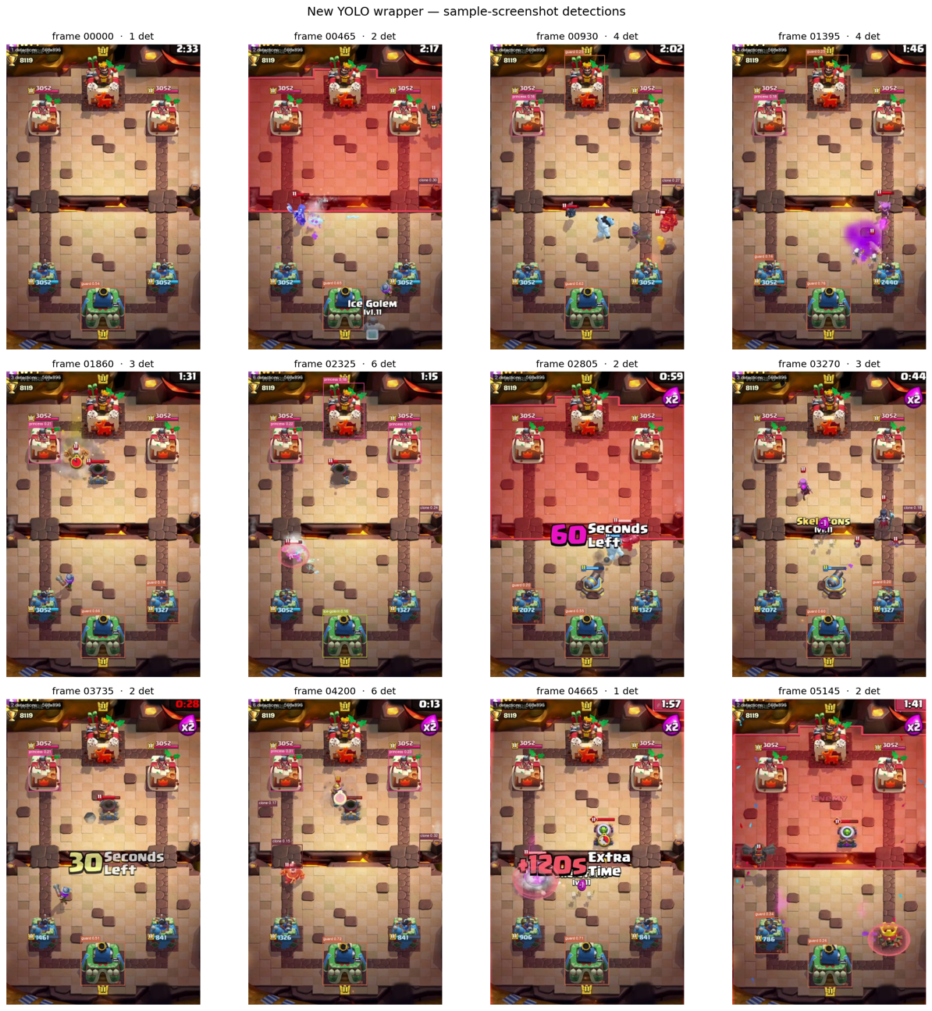
Figure 2:
The number of detections varies per frame (1–6). This variability is exactly what motivates the next two stages.

Stage 3 Multimodal tokenizer
The tokenizer (perception/tokenizer.py) takes a heterogeneous bundle (image patches, YOLO detections, 5 hand-card slots, elixir, previous action, previous reward, RTG, timestep) and produces one unified token sequence per frame. Each token has a learned token-type bias so the downstream attention can tell modalities apart, and they all live in the
same d_model-dimensional embedding space.

Stage 4 Perceiver IO encoder
models/policy/perceiver_encoder.py implements a Perceiver IO (Jaegle et al. 2021). A small set of K=64 learned latent vectors cross-attends the variable-length input token cloud, then runs several self-attention layers among themselves. The encoder is shape-agnostic on the input side: any number of YOLO detections, any number of image patches. Cost: O(M·K) instead of O(M²) for a vanilla Transformer over the same inputs.

Stage 5 Decision Transformer
models/policy/decision_transformer.py is a standard causal Transformer.
The trick is the token layout per timestep:
[ S₁, S₂, ..., S_K, ACT_slot ] ← K Perceiver latents + 1 reserved action slot
Stacked across T = seq_len = 30 timesteps, with a causal mask. The model reads through the action slot at each step to produce the action prediction. RTG, previous action, previous reward, and absolute timestep are into the per-frame tokens before encoding (see Stage 3).

Stage 6 Three policy heads
models/policy/policy_heads.py has three small linear heads:
Head | Output | Loss
Select | one of 4 hand cards or "no-op" (5 classes) | Cross-entropy
Position | a cell on a 36 × 64 grid (2,304 classes) | Cross-entropy
Delay | "play in Δt frames" — 21 bins | Cross-entropy

Total loss is a weighted sum, masked so frames without a labeled human action don't contribute.

5. The most important architectural change
The old StARformer in KataCR processed each frame first with a spatial Transformer over a 32×18 grid of unit-feature cells, then stacked the per-frame outputs into a temporal Transformer. Two stages, two attention operations, fixed order.
The new design is unified:
- Each frame's tokens (patches + detections + cards + scalars) all go through the same Perceiver encoder.
- The Decision Transformer's causal attention then mixes information across timesteps and across the K latents at the same time.
Two practical consequences:
- No hard-coded modality order. Object–object, card–object, time–card relationships are all learned in the same attention.
- Variable input length is free. Adding a new modality (say, audio tokens or chat-bubble tokens) doesn't change the architecture.

6. Does the perception actually work?
Figure 3 aggregates detection statistics across the 12 sampled frames.
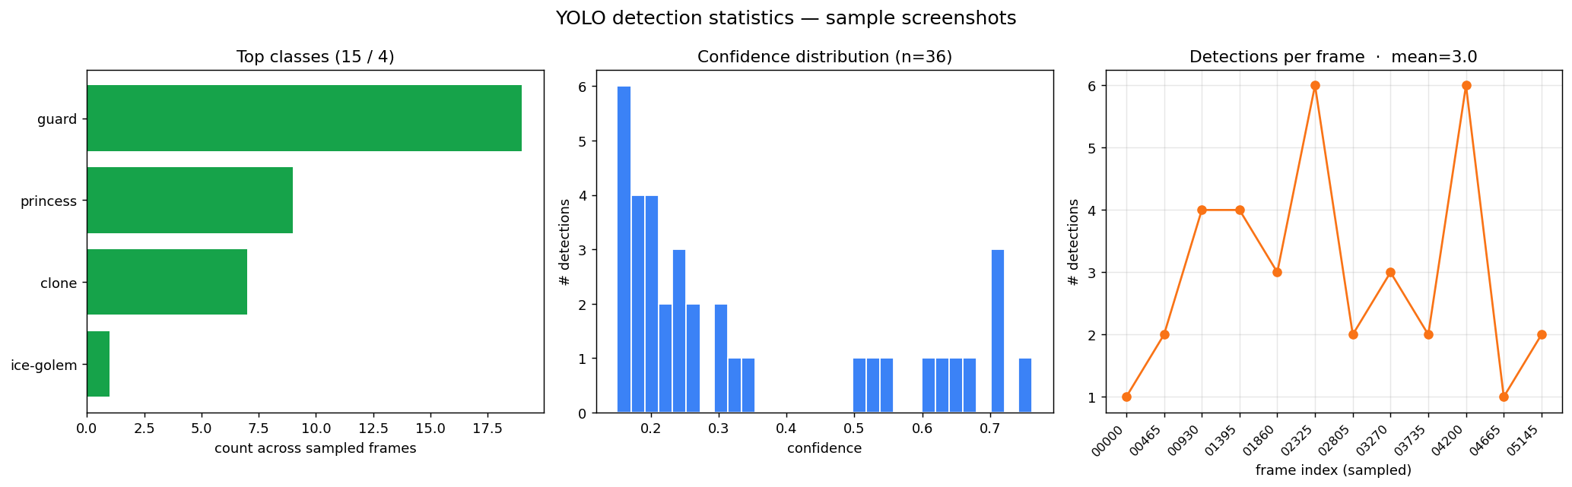
Three things to read off this figure:
1 `guard` dominates the class histogram, which is not correct. It supposed to be the king or queen tower. The reason might be that the process wasn’t sampled and the data are biased. There are four towers visible nearly every frame.
2 The confidence distribution is bimodal with most mass between 0.3 and 0.9. The model is confident in what it does see.
- Detections per frame fluctuate from 1 to 6. This is the empirical evidence that the input length is not constant, and therefore that a fixed-shape architecture (vanilla ViT, fixed-size CNN feature map) would either pad heavily or fail.

7. Does the new model actually train?
Yes. Figure 4 is a real training run on the new pipeline for 5 epochs, 640 gradient steps, on a 5.4M parameter scaled-down configuration that fits on a MacBook MPS device.
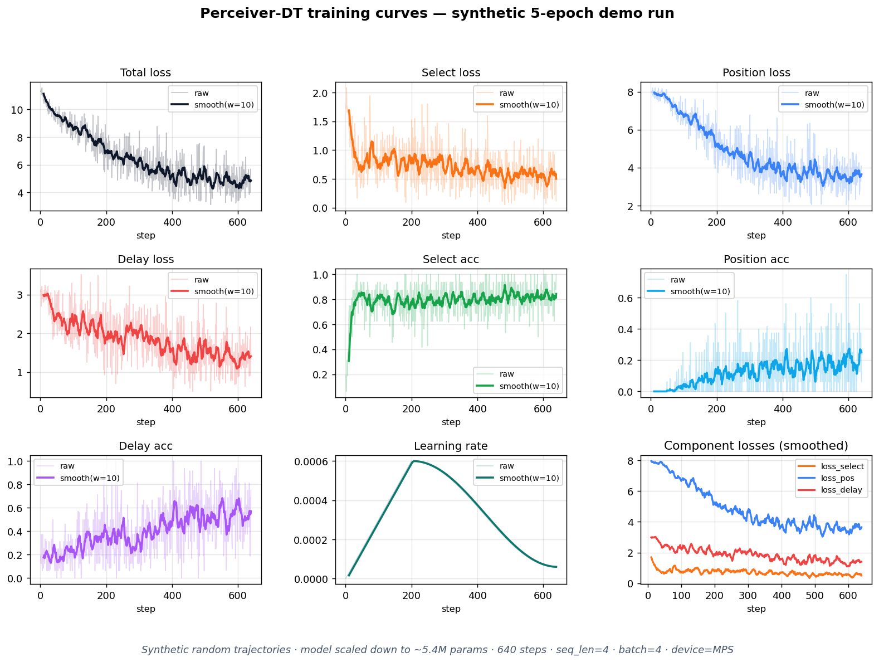Key points:
- Total loss drops from ~11 to ~4.8 smoothly — the model is learning a signal, not just memorizing batch noise.
- Select loss (which card to play) falls quickly because there are only 5 classes.
- Position loss stays the highest the position head has 2,304 classes, which is the hardest signal to fit.
- Learning rate follows a linear-warmup.

8. End-to-end forward pass on a real screenshot
This is the figure I think is one of the most important ones, because it shows the abstract architecture in tensor shapes from a real frame.
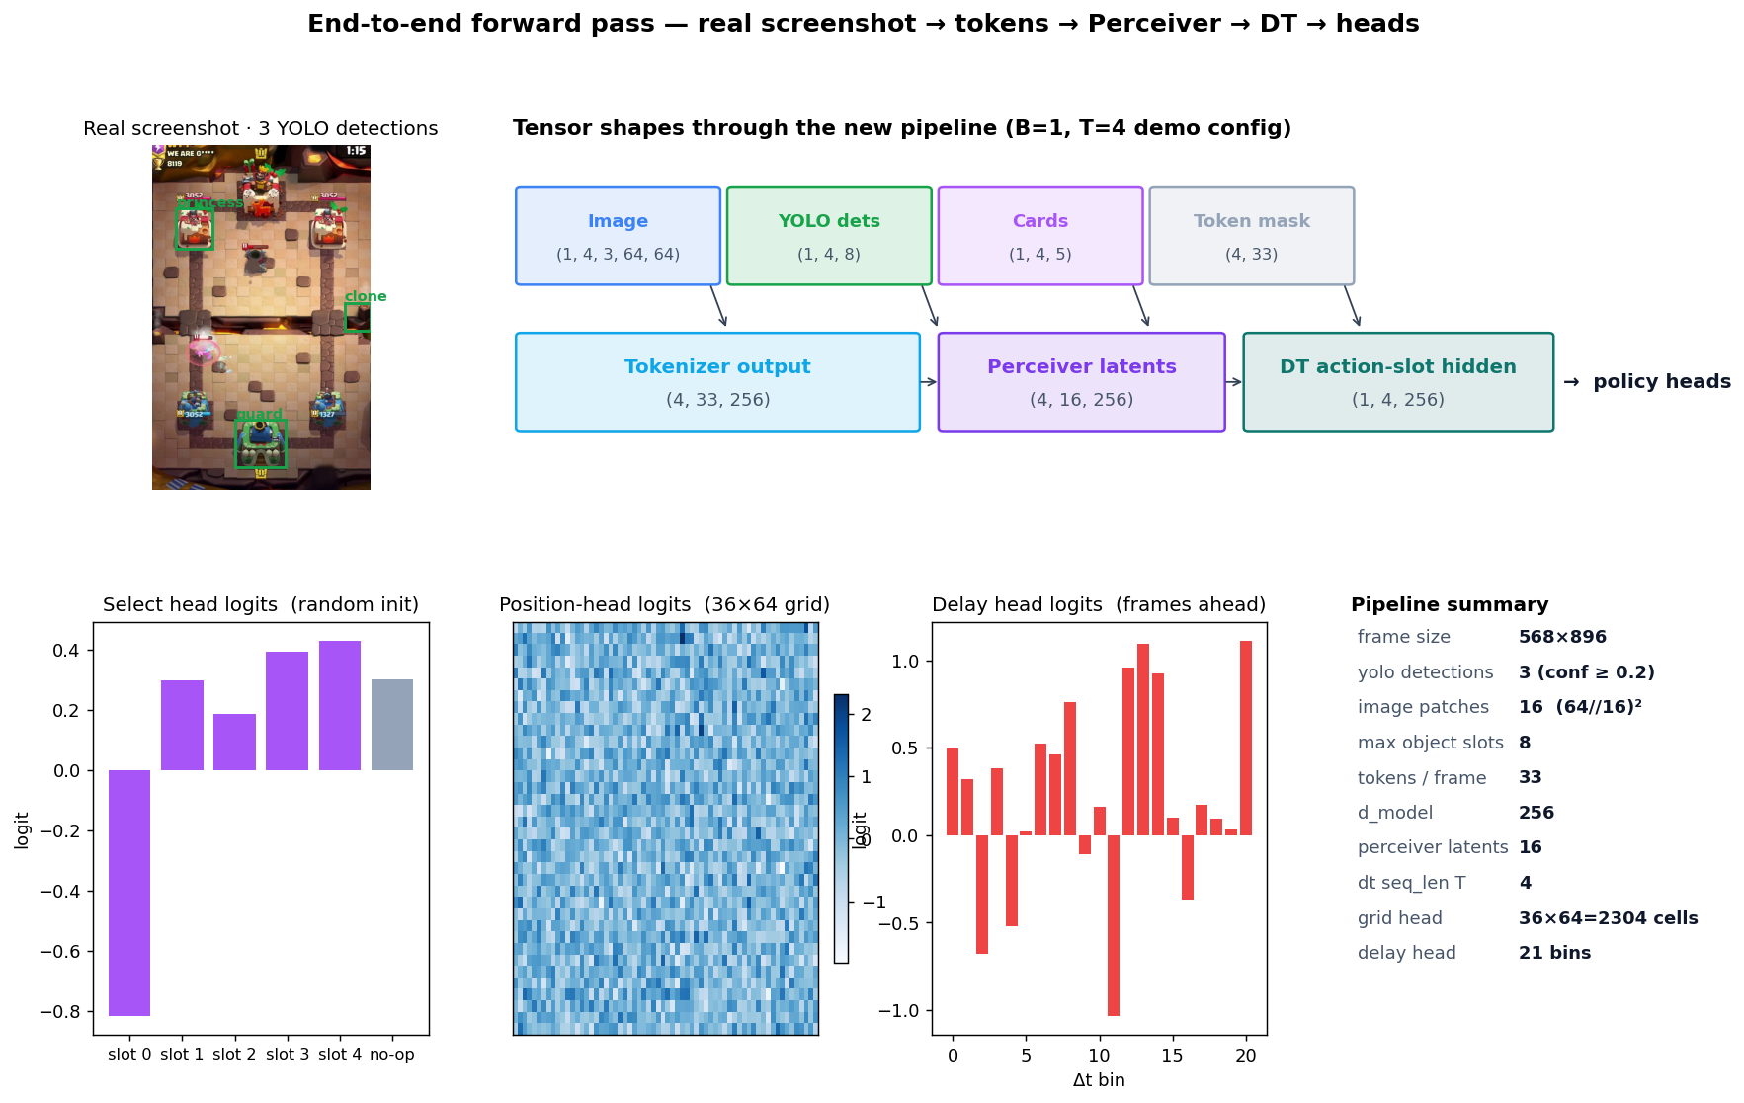The boxes show the actual tensor shapes between stages.
What this figure shows:
- Top-left: the input screenshot with three YOLO detections overlaid.
- Top-right: every intermediate tensor's shape, all the way from raw image to the action-slot hidden state.
- Bottom-left to right: the three head outputs at the last timestep select logits over 5 classes, the 36×64 position logit grid (heatmap), and the 21-bin delay logits.
The point is that all dimensions match. Tokenizer → Perceiver → Decision Transformer → heads compose, and a real frame produces meaningful (if random-init) head outputs.

9. The offline-RL data pipeline
Figure 6 shows the dataset side of the system, using a synthetic trajectory because I haven't collected real replays yet.
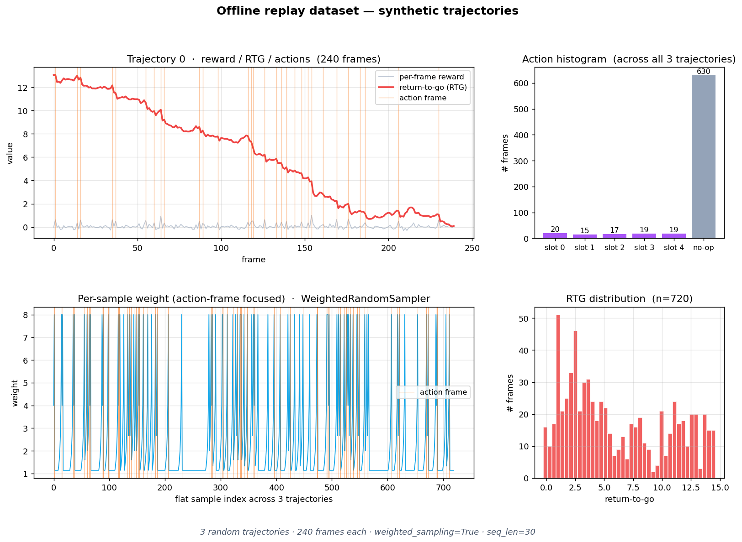
(Top-right) action distribution. (Bottom-left) per-sample weight from the weighted random sampler. (Bottom-right) RTG distribution.
Three design decisions are visible here:
- Return-to-go (the red curve, top-left) is computed backwards from the end of each trajectory. Decision Transformers condition on this at training time so the agent learns "to reach this return, I should act like this".
- `no-op` dominates the action distribution (top-right). In Clash Royale, most frames really are "do nothing"
- The weighted sampler (bottom-left) up-weights frames near a real human action so the model isn't drowned in inactive frames during training.

10. What I removed from the legacy stack
Remove | Reason
PaddleOCR (timer & center-text) | Trajectories are pre-segmented. No need to OCR the clock.
cut_episodes.py (OCR-driven cutting) | Same reason — segmentation is the upstream collector's job.
ResNet card classifier | Cards are passed in as integer IDs and embedded directly.
ResNet elixir classifier | Elixir is an integer 0–10, embedded directly.
SARBuilder glue | Replaced by a clean .npz schema in data/replay_dataset.py.
Old StARformer (JAX/Flax) | Replaced by Perceiver IO + Decision Transformer in PyTorch.
Multi-detector / multi-CNN backbones | Single shared YOLO + single shared Perceiver.

The cleanup deleted ~6 of the 7 GB of legacy data + code that the original repo carried. The remaining new pipeline is 13 Python files, about 1,500 lines.

11. Honest limitations and future work
What this project does demonstrate:
- The full architecture is implemented and runs end-to-end.
- It trains without numerical issues on a small synthetic dataset.
- A real screenshot produces correct shapes through every stage.
- All the legacy clutter is gone.
What it does not yet demonstrate:
- That the model wins games. Real-replay collection is the obvious next step.
- That a full-size configuration (≈30M params, the default in configs/policy_config.py) trains stably. I only ran the scaled-down 5.4M-param version locally.
If I had another two weeks, the priority would be building the replay collector that reads gameplay videos, runs YOLO offline, and labels human action frames manually or via screen-recorded touch events.

12. How to reproduce every figure in this report
See HOW_TO_RUN.md next to this file for the exact commands. In short, every PNG in figures/ was produced by a single Python command and a single matplotlib script, all of them committed to the repo under scripts/.

13. Code attribution and reuse
See ATTRIBUTION.md. Briefly:
- Wrote myself: all 13 Python source files of the new pipeline, the SVG architecture diagram, and all four visualization scripts.
- Reused as-is: the YOLOv8 weights from KataCR, the 344 test screenshots, the PyTorch / Ultralytics / matplotlib
- Implemented from papers: Perceiver IO encoder (Jaegle et al. 2021), Decision Transformer (Chen et al. 2021).

